I want to build a **Sales Forecasting System** that predicts **future sales** using **historical sales data** — categorized by **Territory, Area, and Region**, with **Year-Month granularity**. The system will help management plan inventory, set sales targets, and identify regional growth opportunities.

**🚀 Key Components & Features:**

1. **Data Source:**
   * SQL Server database with historical 176067 sales records.
   * Dimensions: Region, Area, Territory, Year, Month, and SalesAmount.
2. **Backend Framework:**
   * **Flask API** for model training and prediction endpoints.
   * RESTful design with routes like /train, /forecast, /health.
3. **Data Handling Best Practices:**
   * Aggregate sales by Region → Area → Territory hierarchy.
   * Sales by Year Month.
   * Normalize or standardize numerical fields.
   * Handle missing or outlier values before model training.
   * Use rolling averages, lag features, and time-based windows for richer model inputs.
4. **Forecast Needed:**
   * Yearly total sales quantity and price
   * Yearly selected product sales quantity
   * Yearly product wise sales quantity
   * Year/Month wise total sales quantity and price
   * Year/Month wise selected product sales quantity
   * Year/Month and product wise sales quantity
   * --------------------------
   * Year/Month and Territory wise total sales quantity
   * Year/Month and Territory wise selected product sales quantity
   * Year/Month and Area wise total sales quantity
   * Year/Month and Area wise selected product sales quantity

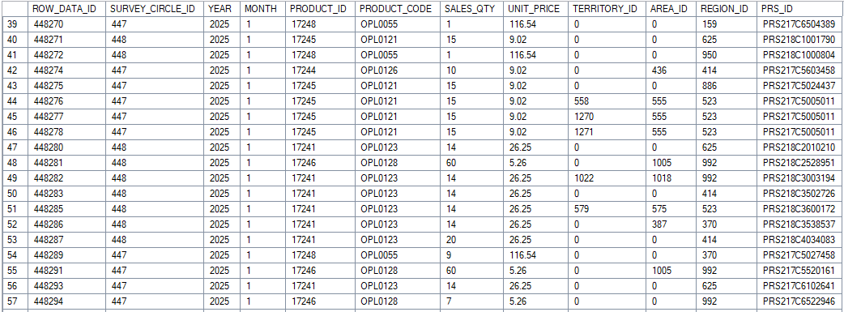

Sales Data

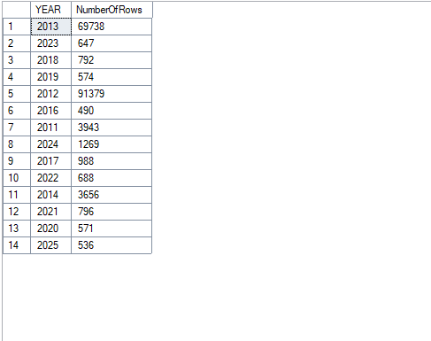

Year wise Sales Count

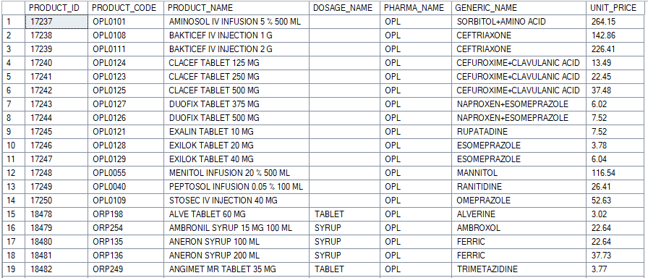

Product List

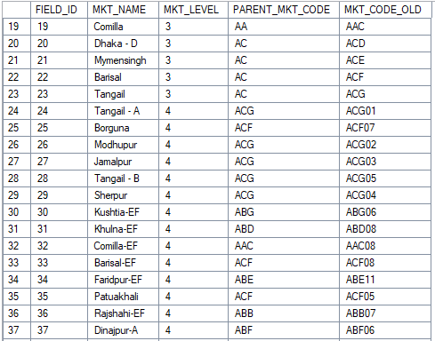

Market Structure (Territory, Area, Region)